**Practical No 3(A).**

**Aim: Configuring Extended ACL.**

**Topology Diagram:-**

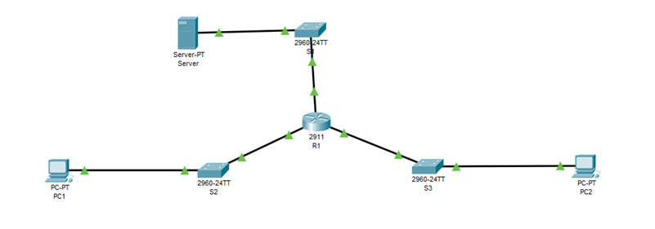

**Assign IP Addresses:-**

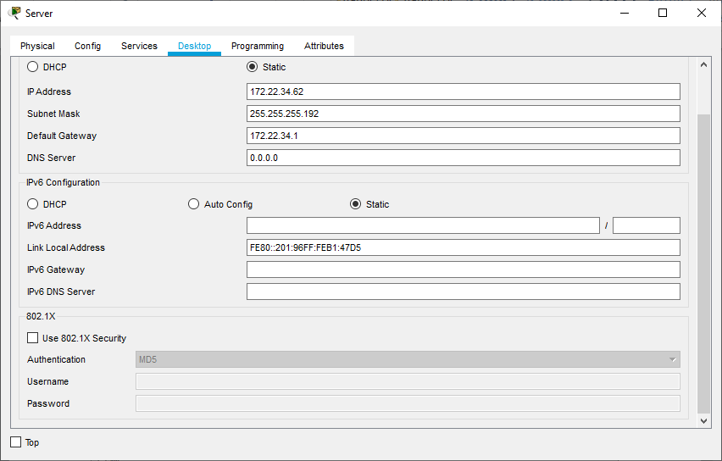

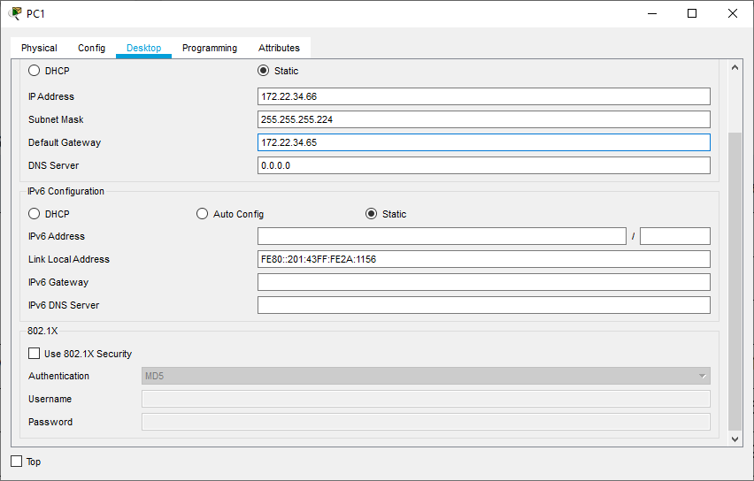

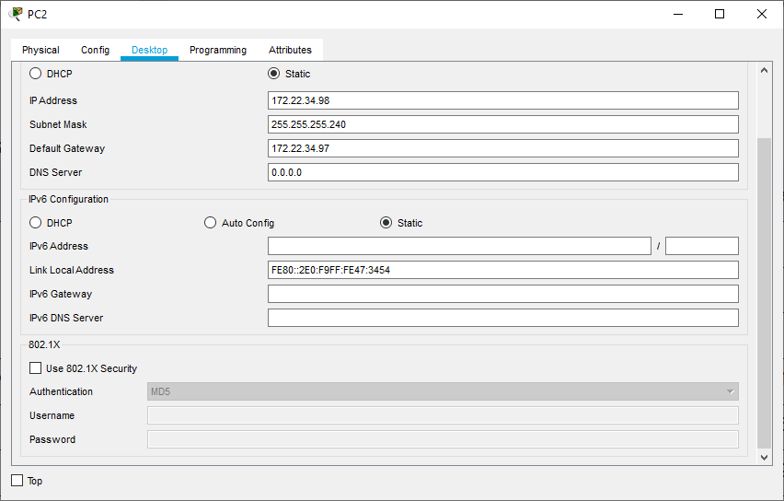

Router>en

Router#conf t

Router(config)#host R1

R1(config)#interface GigabitEthernet0/0

R1(config-if)#ip address 172.22.34.65 255.255.255.224

R1(config-if)#no shut

R1(config)#interface GigabitEthernet0/1

R1(config-if)#ip address 172.22.34.97 255.255.255.240

R1(config-if)#no shut

R1(config)#interface GigabitEthernet0/2

R1(config-if)#ip address 172.22.34.1 255.255.255.192

R1(config-if)#no shut

R1(config-if)#^Z

R1#exit

**Displaying IP Address Details of R1:-**

R1>show ip interface brief

Interface IP-Address OK? Method Status Protocol

GigabitEthernet0/0 172.22.34.65 YES manual up up

GigabitEthernet0/1 172.22.34.97 YES manual up up

GigabitEthernet0/2 172.22.34.1 YES manual up up

**Performing Ping from PC1 to Server and PC2:-**

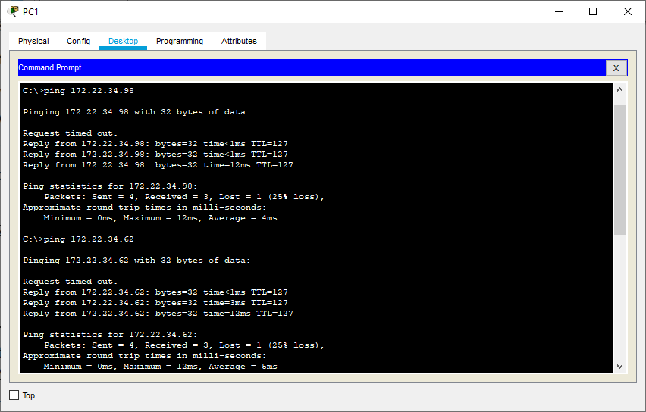

**Performing Ping from PC2 to Server and PC1:-**

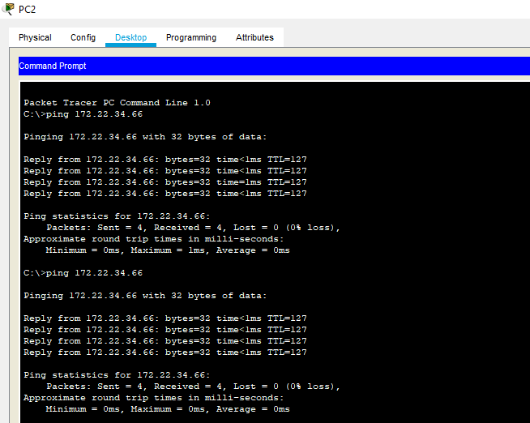

1. Co**nfigure, Apply and Verify an Extended Numbered ACL:-**

**(PC1** needs only FTP access and should be able to ping the server, but not PC2**)**

R1>en

R1#conf t

R1(config)#access-list ?

<1-99> IP standard access list

<100-199> IP extended access list

R1(config)#access-list 100 ?

deny Specify packets to reject

permit Specify packets to forward

remark Access list entry comment

R1(config)#access-list 100 permit ?

ahp Authentication Header Protocol

eigrp Cisco's EIGRP routing protocol

esp Encapsulation Security Payload

gre Cisco's GRE tunneling

icmp Internet Control Message Protocol

ip Any Internet Protocol

ospf OSPF routing protocol

tcp Transmission Control Protocol

udp User Datagram Protocol

R1(config)#access-list 100 permit tcp ?

A.B.C.D Source address

anyAny source host

host A single source host

R1(config)#access-list 100 permit tcp 172.22.34.64 ?

A.B.C.D Source wildcard bits

R1(config)#access-list 100 permit tcp 172.22.34.64 0.0.0.31 ?

A.B.C.D Destination address

anyAny destination host

eq Match only packets on a given port number

gt Match only packets with a greater port number

host A single destination host

lt Match only packets with a lower port number

neq Match only packets not on a given port number

range Match only packets in the range of port numbers

R1(config)#access-list 100 permit tcp 172.22.34.64 0.0.0.31 host ?

A.B.C.D Destination address

R1(config)#access-list 100 permit tcp 172.22.34.64 0.0.0.31 host 172.22.34.62 ?

dscp Match packets with given dscp value

eq Match only packets on a given port number

establishedestablished

gt Match only packets with a greater port number

lt Match only packets with a lower port number

neq Match only packets not on a given port number

precedence Match packets with given precedence value

range Match only packets in the range of port numbers

<cr>

R1(config)#access-list 100 permit tcp 172.22.34.64 0.0.0.31 host 172.22.34.62 eq ?

<0-65535> Port number

ftp File Transfer Protocol (21)

pop3 Post Office Protocol v3 (110)

smtp Simple Mail Transport Protocol (25)

telnetTelnet (23)

www World Wide Web (HTTP, 80)

R1(config)#access-list 100 permit tcp 172.22.34.64 0.0.0.31 host 172.22.34.62 eq ftp

R1(config)#access-list 100 permit icmp 172.22.34.64 0.0.0.31 host 172.22.34.62

R1(config)#interface GigabitEthernet0/0

R1(config-if)#ip access-group 100 in

R1(config-if)#^Z

R1#exit

**Performing Ping from PC1 to Server and PC2 to check the working of ACL:-**

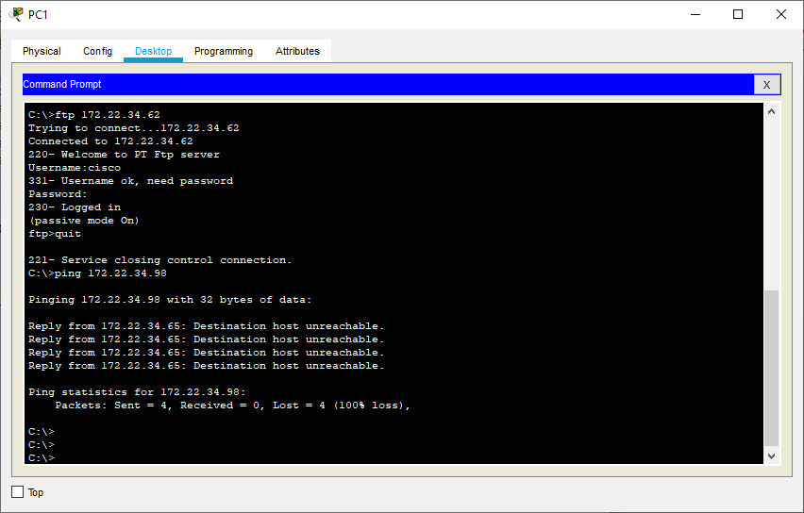

**Configure, Apply and Verify an Extended Named ACL:-**

**(PC2** needs only web access and should be able to ping the server, but not PC1**)**

R1>en

R1#conf t

R1(config)#ip access-list ?

extendedExtended Access List

standardStandard Access List

R1(config)#ip access-list extended ?

<100-199> Extended IP access-list number

WORD name

R1(config)#ip access-list extended HTTP_ACL

R1(config-ext-nacl)#permit tcp 172.22.34.96 ?

A.B.C.D Source wildcard bits

R1(config-ext-nacl)#permit tcp 172.22.34.96 0.0.0.15 ?

A.B.C.D Destination address

anyAny destination host

eq Match only packets on a given port number

gt Match only packets with a greater port number

host A single destination host

lt Match only packets with a lower port number

neq Match only packets not on a given port number

range Match only packets in the range of port numbers

R1(config-ext-nacl)#permit tcp 172.22.34.96 0.0.0.15 host ?

A.B.C.D Destination address

R1(config-ext-nacl)#permit tcp 172.22.34.96 0.0.0.15 host 172.22.34.62 ?

eq Match only packets on a given port number

establishedestablished

gt Match only packets with a greater port number

lt Match only packets with a lower port number

neq Match only packets not on a given port number

range Match only packets in the range of port numbers

<cr>

R1(config-ext-nacl)#permit tcp 172.22.34.96 0.0.0.15 host 172.22.34.62 eq ?

<0-65535> Port number

domainDomain Name Service (DNS, 53)

ftp File Transfer Protocol (21)

pop3 Post Office Protocol v3 (110)

smtp Simple Mail Transport Protocol (25)

telnetTelnet (23)

www World Wide Web (HTTP, 80)

R1(config-ext-nacl)#permit tcp 172.22.34.96 0.0.0.15 host 172.22.34.62 eq www

R1(config-ext-nacl)#permit icmp 172.22.34.96 0.0.0.15 host 172.22.34.62

R1(config)#interface GigabitEthernet0/1

R1(config-if)#ip access-group HTTP_ACL in

R1(config-if)#^Z

R1#exit

**Performing Ping from PC2 to Server and PC1 to check the working of ACL:-**

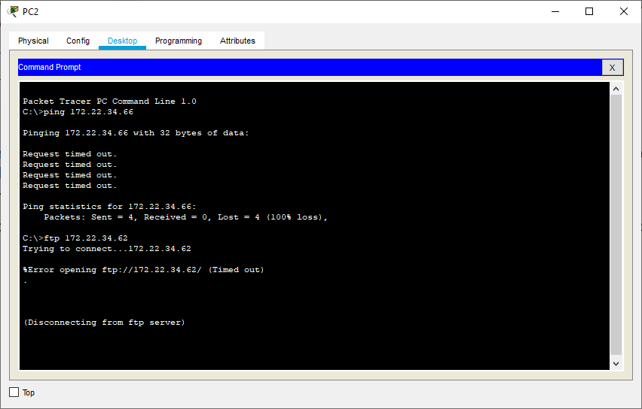

**Checking http connection from PC2:-**

